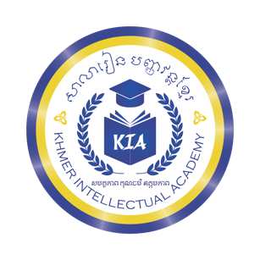
សាលារៀន បញ្ញវន្តខ្មែរ

Khmer Intellectual Academy
សមត្ថភាព គុណធម៌ ឧត្តមភាព

No | Current Classes |  |  | New Classes for 2025-2026
 | Teacher's Name | Level | Sts | Teacher's Name | Level | Sts
1 | Yin Thary | Found | 16 | Yin Thary | Found (New) | 0
2 | Pov Pisey | IntroA | 29 | Sin Sopheakpov | IntroA (Thary) Level1 | 16
3 | Sami Molika | 1A | 32 | Sami Molika | 1A (Pisey) Level3 | 29
5 | Soriya Sinaroth | 2B | 26 | Pov Pisey | 2A (Molika) Level5 | 32
6 | Neang Menghour | 2B | 19 | Soriya Sinaroth | 3A (Sinaroth) Level7 | 26
7 | Sey Kassy | 3A | 29 | Neang Menghour | 3A (Menghour)Level7 | 19
8 | Ung Samnang | 6A | 9 | Keo Chakrya | Blueprint 4A (Kassy) Level 9 | 29
 |  |  |  | Sey Kassy | Blueprint 7A Level12 | 9
9 | Soriya Sinaroth 6-7 | 3A | 8 | Soriya Sinaroth 6-7 | Blueprint 4A Level 9 | 8
10 | Yin Thary 6-7 | IntroA | 6 | Yin Thary 6-7 | 1A | 6
Part-time Teachers
Total: 179
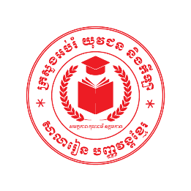
Prepared by Academic Team

July 15, 2026
ស៊ី សុវណ្ណារ៉ា

